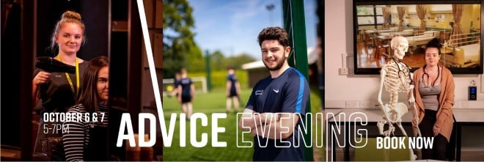
Dear Parents/Carers
I'm pleased to let you know that following the easing of lockdown restrictions and the gradual return to 'normality', Buxton & Leek College will be holding our first on-campus recruitment events from October, starting with our Advice Evenings. These are great events for your Year 11s who will be starting to think about what their options are after their GCSESs:
Leek Campus  Stockwell Street, Leek, ST13 6DP  Wednesday 6 October 2021, 5pm-7pm | Buxton Campus  Devonshire Dome, Devonshire Rd, Buxton, SK17 6RY  Thursday 7 October 2021, 5pm-7pm
At the Advice Evenings, prospective students will be able to:
- Find out what programmes are offered at BLC: vocational qualifications, apprenticeships and T Levels
- Ask any questions you may have about applying for a programme with us
- Find out more information about life as a student at BLC
- Meet our Support teams to find out what help and support is available to students
- Meet our friendly and experienced tutors and staff
- Visit our campus and see our facilities
We are also still enrolling students for this academic year, up to October Half-Term, so if you have contact with and previous Year 11s who still haven't managed to secure a place, then these events will be really useful for them also as they can enrol on the night!
To book their place on any of our events prospective students can visit our website, email enquiries@blc.ac.uk or call us on 0800 074 0099.
Also, I'd like to ask you to let me know if there are any events at your school that you would like Buxton & Leek College to attend, if you haven't already done so. Whether its an assembly, careers fair, workshop/presentation or anything else, we'd be happy to help.
Many Thanks
Suzi Lawrence - Buxton & Leek College

