Changes to timings of the school day
We are really excited by some changes we are making to the school day. From Monday 31st October students will have a new lesson on their timetable called personal development. During this lesson, students will have personal development sessions (on RSE, Health, Careers and living in the wider world), reading sessions and academic tutorials. To accommodate this new session, the timings of the school day will change (see diagam below). Please note that our school start and finish times are unaffected.
New PSHE Delivery
We are really pleased to be able to move from our full days to a more regular slot to deliver our personal development sessions. (There may be infrequent occasions when it is necessary to take students off timetable for an hour for a workshop etc.) Having a regular timetabled teacher to deliver these sessions will help to build the relationships which are important when discussing more sensitive topics, and the chance to revisit topics regularly will help to embed the learning. The topics will remain the same in each year and are available to see on our website.
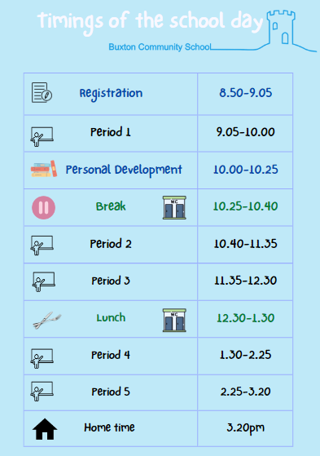

Why Reading Is So Important

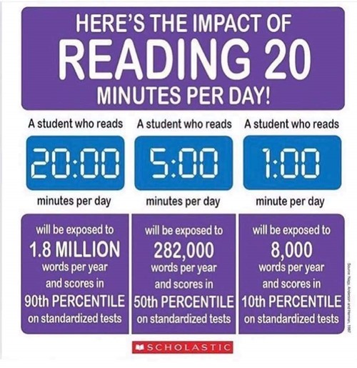
We are really excited to launch our new school-led reading programme for all students in Years 7-11. At Buxton Community School, we value the skill of reading for learning and seek to find ways to enable students to extend their skill and love of reading as well as improving their wider cultural knowledge of the world around them. After half term, three times a week during our new PD slot, a member of the teaching staff will be reading to students, covering 4 or 5 novels over the course of an academic year.
The school-led reading programme has been set up to keep our students reading and accessing high quality texts and stories from diverse cultures, transitions, and time periods. By reading to them, we can supplement the text with valuable context that boosts student knowledge and understanding, drawing links and parallels to content in the wider curriculum as appropriate. We are dedicated to ensuring that progress is made at every stage of your child’s learning journey and are sure that this new initiative will provide endless opportunities for that. We invite parents to regularly engage with their child about the books being read.

Reading Sessions @ BCS
  - Students will have their own copy of a chosen book, but their teacher will be reading to them. The chosen texts for each Year group are as follows:
Year 7 – Trash by Andy Mulligan

Year 8 – A Monster Calls by Patrick Ness

Year 9 – Refugee Boy by Benjamin Zephaniah

Year 10 – The Women in Black by Susan Hill

Year 11- The Nickel Boys by Colson Whitehead

Black History Month


This October has seen our school celebrating ‘Black History Month’ (BHM) to enrich the learning experience and broaden the understanding of our students. This has included history lessons on the Windrush immigrants, black Tudors and diversity in the trenches during the First World War. Elsewhere in the curriculum, music and science lessons have featured the contributions of black musicians and scientists over time, and English lessons have focused on the poetry of Maya Angelou and hip-hop artists such as Tupac Shakur. We also remain committed to diversifying our whole curriculum, not just for BHM, to ensure that it becomes more inclusive and reflective of British society and the world we live in today.

BCS FESTive

Team BCS would like to invite you to their Christmas event: BCS FESTive.

The event will be held from 5pm on Friday 9th December.

The whole family is welcome! There will be stalls, Christmas crafts, Santa's grotto, live reindeer (hopefully), plus live music and fun and games.

Entry will be £1

School Led Tuition
We have made a really positive start to our additional in-school tutoring programme this year; lots of students are now receiving small group support in a range of subjects with plenty more to follow. The sessions are in place to bridge learning that may have been affected due to the Covid pandemic and, along with being enjoyable, enable the students to become more knowledgeable and confident. This initiative will run throughout the year and we kindly encourage you to support the school if your child is invited to attend by either Mrs Warrington or Mrs Lowe.

Rewards
Our reward system, which recognises effort above and beyond our standard expectations, is up and running. At the time of writing, over 38,499 positive points have been awarded, clearly demonstrating students’ positive engagement and behaviour. Our first cycle of RAP rewards were awarded today, Friday 21st October. On this occasion we have rewarded students with Love to Shop Vouchers. The plan for the rest of the year offers all students the chance to be rewarded in a variety of different ways.

Buxton’s Sixth Form
Our new Y12 students have made a great start to the term and are enjoying the freedom that comes with Sixth Form life. As well as studying for three A levels, we encourage all our Sixth Formers to take part in an enrichment programme and to go beyond the academic curriculum to gain skills and new experiences. As part of our new reading initiative, 15 of our Sixth Formers had training this week to become Reading Leaders who will work with younger students to help them become more fluent and confident readers. Other students are helping to run clubs and offering their expertise in lessons and after half term we will launch our popular Duke of Edinburgh programme.
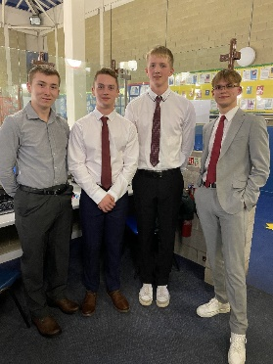
Y13 students are busy preparing for their next steps. They’ve recently done a week of mini mock exams to review their Y12 learning; have had formal interviews with our local Rotarians who were incredibly impressed by their CVs, smart presentation and friendly and confident conduct and are currently working on their UCAS applications or researching apprenticeships. Two UCAS applications for Oxbridge colleges have been submitted and I’m sure you will join me in wishing Amelie, Reuben and indeed all our Sixth Formers good luck with their applications over the next couple of months.

Key Dates
Date | Year Group | Event
2nd November | Year 11 | Parents’ Evening
9th November | Year 13 | Parents’ Evening
16th November | Year 9/10 | Theatre Trip
24th November | Year 7 | Parents’ Evening
W/C 5th December | Year 11 | Mock Exams
8th December | Year 12 | Parents’ Evening
15th December | Year 10 | Parents’ Evening
15th December | Year 7/8 | Theatre Trip

In Other News
Sporting Successes:
Already this year we have had a significant number of sporting successes:
Date | Team | Opponents | Result
28th September | Y7 Boys Football | New Mills | Won 6-0
28th September | KS4 Boys Football | New Mills | Won 9-0
11th October | Y7 Boys Football | Chapel School | Won 4-2
11th October | Y8 Boys Football | Chapel School | Lost 2-0
11th October | Y8 Netball | Chapel School | Lost 28-2
11th October | Y10 Netball | Chapel School | Lost 9-7
14th October | Y7 Boys Football | St Thomas More | Won 2-1
14th October | KS4 Football | St Thomas More | Won 5-0
18th October | Y9 Boys Football | St Thomas More | Won 4-2
18th October | Y7 Netball | St Thomas More | Won 8-0
18th October | Y8 Netball | St Thomas More | Lost 5-0
18th October | Y9 Netball | St Thomas More | Won 14-13

