Simple Yoga Stretches
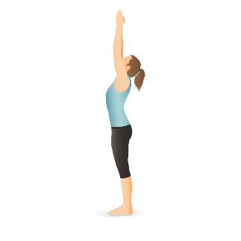
Mountain Pose (Tadasana):
Stand with your feet together and arms by your sides.
Engage your thighs, lift your chest, and reach your arms overhead with palms facing each other.
Keep your shoulders relaxed, and gaze forward. Hold for 30 seconds to 1 minute, breathing deeply.
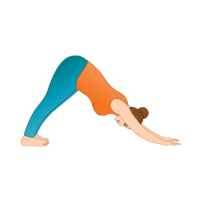
Downward-Facing Dog (Adho Mukha Svanasana):
Start on your hands and knees. Align your wrists under your shoulders and knees under your hips.
Lift your hips towards the ceiling, straightening your legs.
Press your palms into the mat, keeping your head between your arms.
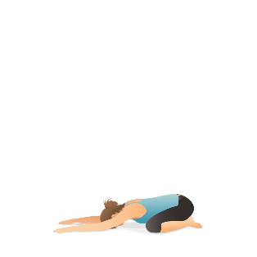
Hold for 30 seconds to 1 minute, focusing on your breath.
Child's Pose (Balasana):
Kneel on the mat with your big toes touching and knees apart.
Sit back on your heels, then reach your arms forward on the mat.
Rest your forehead on the mat and relax in this position, taking deep breaths.
Seated Forward Bend (Paschimottanasana):
Sit on the floor with your legs extended in front of you.
Inhale, lengthen your spine, then exhale and hinge at your hips to reach toward your toes.
Hold onto your shins, ankles, or feet, keeping your back straight.
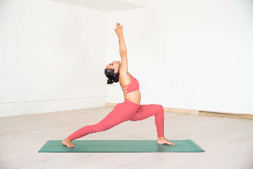
Warrior I (Virabhadrasana I):
Start in a standing position and step one foot back, keeping the front knee bent.
Square your hips to the front, and reach your arms overhead, palms facing each other.
Keep your back leg straight and toes pointing slightly outward.
Hold for 30 seconds to 1 minute, then switch sides.

Relaxing music: https://www.youtube.com/watch?v=eKbfUtLoQwE

