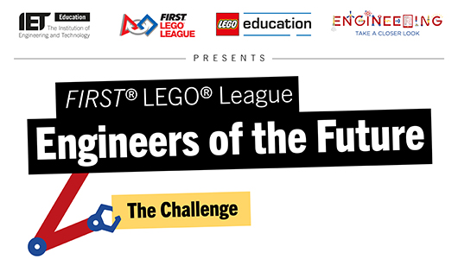

Dear Team stE-V-3,
The IET, LEGO Education and HM government are delighted to congratulate you on being selected as a winner of the Engineers of the Future Challenge. The judges were very impressed with your film and would like to invite your team to participate in the Engineers of the Future Showcase event to celebrate the Year of Engineering at the Houses of Parliament, Westminster on Wednesday 12th December from 12:00 – 16:00.
We feel that you will be excellent ambassadors and can help to promote the importance of STEM education and engineering. The Future Showcase event will be your opportunity to engage with MPs and showcase the work and skills you have developed in FIRST® LEGO® League.
You have also won FREE entry to the INTO ORBIT FIRST® LEGO® League season for both you and the team you nominated. We thought it would be fun for you to pass on this good news to your nominated team and find out at which INTO ORBIT tournament they wish to compete. We urge you to contact the IET quickly to ensure that both teams are registered in the tournaments of their choice so that they receive their challenge sets.
As a further part of your prize, the IET will send two LEGO® MINDSTORMS core sets and two expansion sets for you and your nominated team as soon as you confirm your delivery address. Please pass on the MINDSTOMRS equipment to your nominated team and help them to get going. The IET will also be in touch to confirm the travel arrangements for the trip to the Houses of Parliament. The nominated team are not included in this visit.
Congratulations on all your hard work. We are looking forward to seeing you at the Houses of Parliament. Please get involved online using the following handles and hashtags: @FLLUK, @TheIET, @YoEgovuk, @LEGOeducationUK and #YoE.
Well done!
Warm regards,
The IET FIRST® LEGO® League Team
Contact the IET at: mworkman@theiet.org or lwalton@theiet.org

