Revision Computer Science GCSE 1-9
www.teach-ict.com (Username = sk179ea Password = bitmap9)
https://www.ocr.org.uk/qualifications/gcse/computer-science-j276-from-2016/ (specification)
https://www.ocr.org.uk/qualifications/gcse/computer-science-j276-from-2016/assessment/ (past papers and mark schemes)

In school – All Users, IT and Computing, GCSE 1-9., revision and papers
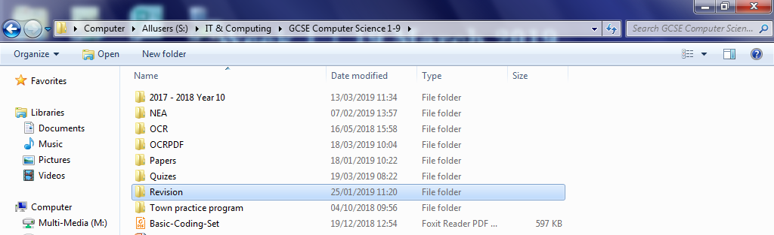
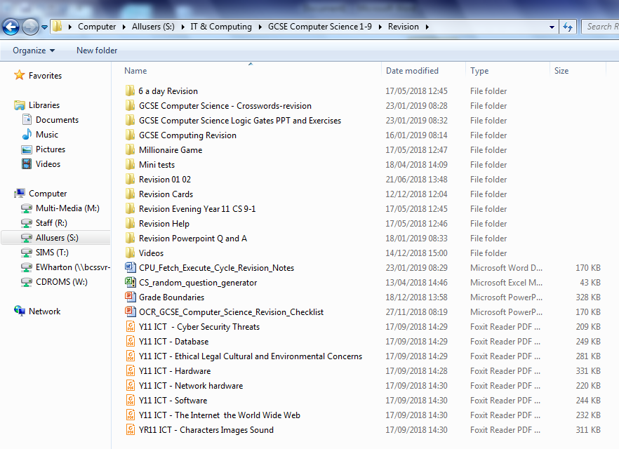

GCSE Revision Book
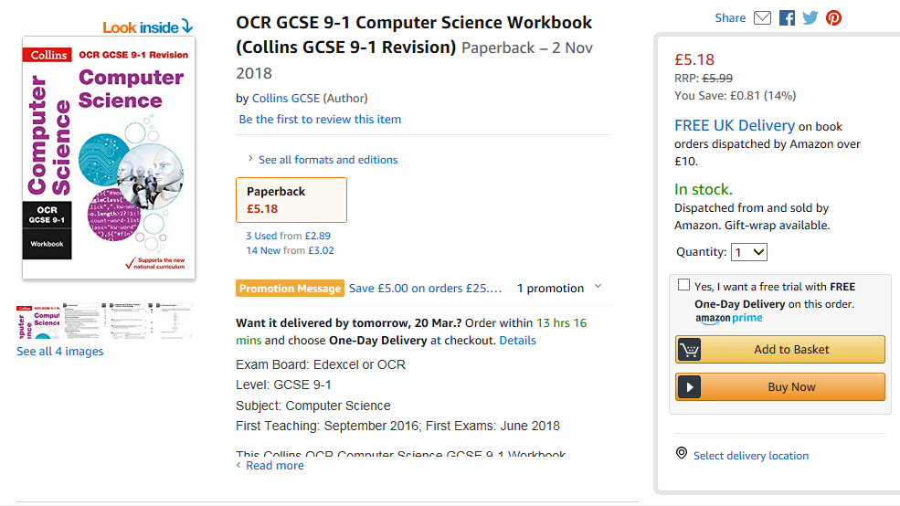
In lessons – condensing notes, practising past questions, quizzes and recap
Homework’s = Past paper question most weeks now

