

23rd May 2019
Dear Parent/Carer
This year Activity Day takes place on Thursday 11th July 2019 and provides an opportunity for all students to participate in a trip or visit.
We have the opportunity for Sixth Form to visit Liverpool on Activity Day. It gives students a chance to enjoy the city, visit The Albert Dock and go shopping in Liverpool One.
There is also an opportunity for students to visit Break Out Liverpool.
The cost of the trip is £15 for transport only or £30 if your child wishes to visit the Break Out Room.
Full payment of this trip is expected by Monday 10th June 2019. All payments to be made online through Parent Pay.
Please return the attached consent form to Mrs. Mulhall.
Yours sincerely
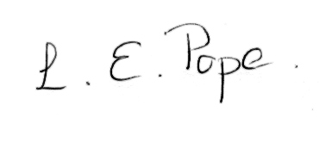
L Pope
Assistant Headteacher

……………………………………………………………………………………………………………
I consent to my son/daughter to attend the Liverpool Trip on 11.07.2019.
STUDENT NAME ………………………………………….…………… FORM ………………….
I am visiting Break Out Liverpool Yes
No

Signed ………………………………………………….. Parent/Carer


