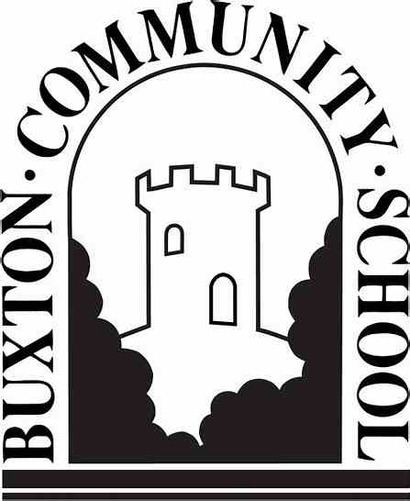
Buxton Community School supports
Black History Month 2020
Staff name: Emma Wentworth
I am inspired by Tommie Smith and John Carlos
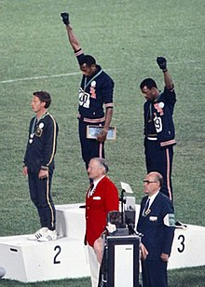
During their medal ceremony in the Olympic Stadium in Mexico City on October 16, 1968, two African-American athletes, Tommie Smith and John Carlos, each raised a black-gloved fist during the playing of the US national anthem, "The Star-Spangled Banner". While on the podium, Smith and Carlos, who had won gold and bronze medals respectively in the 200-meter running event of the 1968 Summer Olympics, turned to face the US flag and then kept their hands raised until the anthem had finished. In addition, Smith, Carlos, and Australian silver medallist Peter Norman all wore human-rights badges on their jackets.
In his autobiography, Silent Gesture, published nearly 30 years later, Smith revised his statement that the gesture was not a "Black Power" salute per se, but rather a "human rights" salute. The demonstration is regarded as one of the most overtly political statements in the history of the modern Olympics

